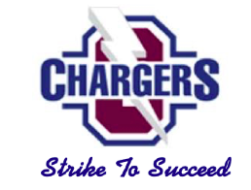
Chasco Middle School

“Meet the Teacher” Event

August 5 (9AM-11AM) & (1PM-3PM)
** Schedules are only provided if the On-line Parent Registration process is complete.

We would like to welcome you to the start of the 22-23 school year and invite you to participate in our new “Meet the Teacher” event. The purpose of this event is to help families get their student’s schedule for the new year, update family/parent contact information, pay school fees, familiarize students with our school, and most importantly to “Meet the Teacher”!

Step #1: Log-in to your Parent Portal and complete the 22-23 school registration process.
- If you accessed myStudent last year, you need to activate your account for the 22-23 school year. To do so, please log-in to myStudent by using your log-in info from last year. Once you have done so, please continue to Step #2
- If you do not have a myStudent account, you will need to create one to complete the registration process. If you need assistance, you can report directly to the media center where one of our staff members will be happy to help. We have sent your Parent PIN# which is REQUIRED to create the account school to your email address. Once you have created your account, please log-in to myStudent and continue to Step #2

Step By Step Video on How to Create a myStudent Account:
https://livepascok12fl.sharepoint.com/:v:/s/myStudent_University/Eeau3-WIlEJJgmNvptlsSzwBKu-hWeAp4szGCpHLGmSLYg?e=iIamBZ

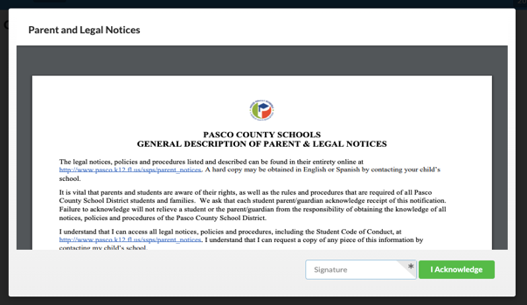
If you need technological assistance with creating an account, please do not hesitate to email myStudenthelp@pasco.k12.fl.us as they are available to provide aid.

Step #2: Acknowledge the Legal Notices
- Once you log-in to myStudent, the “Parent and Legal Notices” will appear on
the screen. Each of the notices includes hyperlinked documents that can be
opened by clicking on the links provided. Once you have reviewed the notices,
please type your name in the “Signature” box and click on “I Acknowledge”.
Once you have done so, please continue to Step #3

Step #3: Validate your Address/Emergency Contact Info in myStudent
Step-By-Step Video of this process: https://tinyurl.com/yy5m964y

- After clicking on “I acknowledge” you will be taken to the myStudent portal screen. Here you will be asked to verify or update the emergency contact information for your student(s). This is the information that was gathered from you during our typical Orientation Day when you filled out the “Emergency Contact Card”
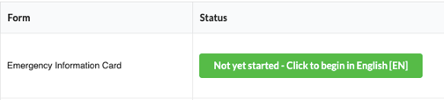
- For each student that you have enrolled in Pasco County Schools, you will see a box that allows you to review/update the contact information:
- To begin the process, please click on the green button entitled “Click Here to Begin”

- You will be asked to verify the student ID#, the date of birth, information on other siblings in Pasco, verify the home address, verify custodial status for the student, verify emergency contacts, have an opportunity to load legal documents related to custody, update medical information, consent for emergency medical treatment, and finally submit these records for your child. Please note that you will be asked to do this for each student that you have enrolled in Pasco County Schools.
- You will be able to update records as needed by typing the information into the provided fields. This information will be reviewed by school staff prior to updating the information in the system. Please note that some changes will require further documentation depending upon the specific change that is submitted to the student records.
- If the information is correct and does not need to be changed, then you will have an option to indicate that as well and the records will remain unchanged in myStudent.
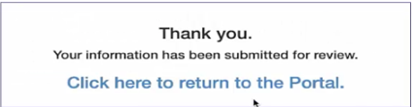
- After clicking on the “Submit and Finish” button you will see a screen thanking you for completing this process and providing you with a link back to the Student Portal. Please click on the link
to return to the portal and complete the same process for all your other
students. Once you have completed this process for all your students,
please continue to Step #4
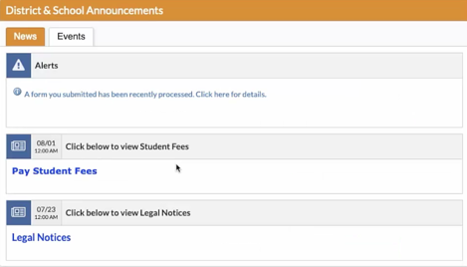
Step #4: Pay Fees & Fundraiser Opt-Out/
- Once you have returned to the student portal, please click on the option
labeled “Pay Student Fees”
- This will take you to the log-in page for the Student Quick Pay Portal.
Parents who have previously paid fees using the Student Quick Pay
Portal can go ahead and log-in using their credentials. If you have
not used the Student Quick Pay Portal previously, please click on the
“Activate Parent Account” option to create your log-in credentials and then log-in to the Student Quick Pay Portal.
- Once you log-in, you will see the name(s) of your student(s) at the top of the screen. Please click on the name of each student to see the fees associated with their schedule.
- Our school has other fees that can be purchased as well at this time. These items are located at the bottom of the screen in the area marked “Other Items”. Included in this category is our Fundraiser Opt-Out fee. (Field Trips can be paid in this manner as well.)
- Please click on whichever item(s) that you are interested in purchasing. When you click on an item, a pop-up window will appear with more information about that item. Some of the pop-up windows will ask for additional information (shirt sizes, sports, etc.) to be filled out and once the form is completed you can hit the “Add to the Cart” button to purchase the item.
- Once you have reviewed the fees for your student(s) and have added the “Other Items” that you would like, please click on the shopping cart icon in the upper right-hand corner of the screen to access to fee payment screen.
- Please note that the amount listed next to the shopping cart icon is the total fees selected for ALL the students that you have enrolled in Pasco County Schools.
Please review the fee summary that is listed on the fee payment screen and then complete the fields on the screen with your payment information. Please click on “Submit Payment” to finish paying your fees. Once you have done so, please continue to Step #5

Opt-Out Fundraiser Information:
Why opt out for $25…

- Students do not participate in the Principal’s Fundraisers (Fall/Spring)
- Students still get to participate in the celebrations for these fundraisers
Step #5: Print Student Schedule
- After paying the fees, please return to the student portal and find your student(s) name on the left-hand side of the screen.
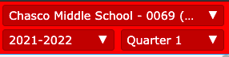
- Please click on the name of your student to access the options menu for that student. Be sure to look in the upper right- hand corner to ensure that you are on the 2022-2023 school year (this is a drop-down menu) and on Quarter 1 (again, a drop-down menu).
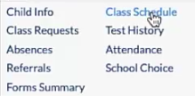
        - Please click on the link labeled “Class Schedule” to view the class schedule for
the student
        - On the schedule page, you can click on the “Print Schedule” button to either print the schedule or download a copy to your computer. Students are encouraged to take a picture of the schedule on their phone in addition to printing a copy. Once you have done so, please continue to Step #6

Step #6: Review Transportation Info
- If your student will be utilizing a school bus, please click on the “Child Info” link located in the same menu as the class schedule link. Clicking on this link will open new screens with specific information for the student. If your student will not be utilizing a school bus, please continue to Step # 7
- Please use the scroll bar to navigate through the different information screens available for your student. Click on the option labeled “Transportation Routes” to see the bus information for the student:
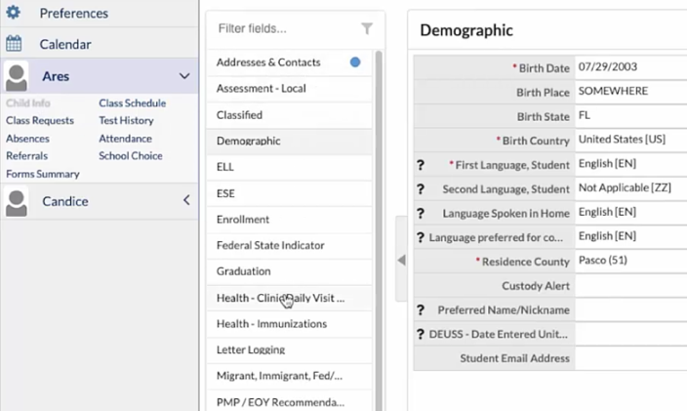
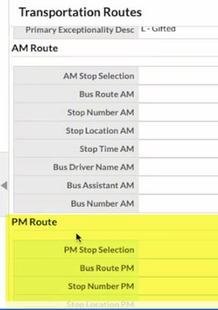
                - Information will include the location of the AM & PM bus stops, the AM & PM Bus #, as well as the designated AM pick-up time.
                - Please encourage your student to take a picture of the bus information on their phone

Step #7: Title One Parent Feedback – As a part of our continued efforts to involve families in their children’s education, we ask that all parents read and give feedback on Our Family Engagement Plan. You can find our Family Engagement Plan by using the attached QR Code. Please complete the feedback section using the link at the end of document. 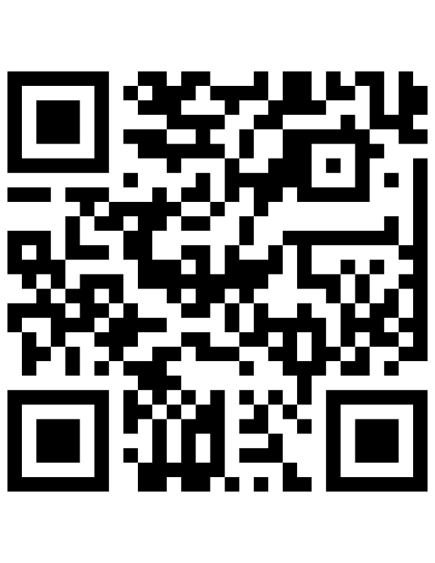
Step #8: VISIT OUR CAMPUS - Please bring your student AND the printed copy of their schedule to CHMS. Parents/Students will be able to enjoy a self-guided tour of our campus and will be able to visit the classroom of each of their teachers. Our teaching staff will be available in the classrooms, where students/parents will be able to “Meet the Teacher” On August 5th from 9-11 AM to 1-3 PM.

IMPORTANT: If you were unable to complete steps 1-7 at home, feel free to report to our school media where we will provide both computers, printer, and staff members to assist you.

IMPORTANT - Parents of 7th Grade Students:
One dose of tetanus-diphtheria-pertussis (Tdap) vaccine is required by state law for students entering 7th grade. Please submit a copy of Florida Certification of Immunization (Form DH 680) to our clinic assistant, Nellie Champion at the following email address:
nchampio@pasco.k12.fl.us

For more information, please visit the District Immunization Information page: http://www.pasco.k12.fl.us/ssps/page/immunizations

IMPORTANT – Message regarding School Lunch:

The federal government is ending USDA free meals for all students SY 22/23. We operate under National School Lunch Program; therefore, we will be returning to Free, Reduced or Paid meals. View our new menu prices for the 2022 - 2023 school year as well as other important lunch information by visiting this site. https://connectplus.pasco.k12.fl.us/do/fns/pascoschoolmeals/

Free/Reduced Lunch:
If you would like to apply for Free & Reduced Lunch for your student(s) – please click on the following link:

If you need help with this process or have questions, please contact Mrs. DeVenny, our Cafeteria Manager, at 727-774 -1278 or stop by our cafeteria to complete the process with her or a member of her staff.

Other Points of Interest:
School Lunch Account:
If you would like to pay online for your child’s school lunch, please click on the “My School Bucks” image below to go the website to sign-up for an account:

Chasco Clothing Closet: Need help with school clothes? We are happy to help! We have a portable full of school clothes to send your student back to school in style. Everything in the Chasco Clothing Closet is free of charge. If you would like to check it out please stop by the closet from 9-11 or 1-3.

School Supplies: No time to shop for supplies… no worries. Simply stop by the cafeteria where our 8th grade teachers will be happy to sell you everything you need for back to school.

