Brandon Dahlin-Bracciale, Principal
Cory Sommers, Assistant Principal
Terry Yohn, Assistant Principal

8th Grade Promotion Ceremony – Information & Accelerated Release Form

Chasco Middle School is proud to announce the 2021-22 8th Grade Promotion Ceremonies. As COVID-19 restrictions have been revised, we will be hosting an in-person Promotion Ceremony. However, due to the size of our gym, students will be limited to three guests each. Students will receive tickets to provide to their three guests. In addition, we will be broadcasting the ceremony via Facebook live so parents can view these ceremonies remotely. We will post the link for the live feed on our school website, via social media, and through our school Messenger service prior to the start of the event. Our intention is to capture as much of the event as possible and to feature each student as their name is called for promotion. We will also be recording this event and will post it so that families can view it together after it has taken place.

- The Promotion Ceremony will be held in the Chasco Middle School Gym on Monday, May 23rd from 9:00 A.M. to 11:00 A.M.

ONLY 8th grade students who have met high school enrollment requirements are invited to participate in the Promotion Ceremony. Students who have not met the enrollment requirements will remain in the learning lab to continue working on meeting the requirements.

We know that parents want to capture pictures as their student(s) name is called. Please be considerate of other families by taking photos as your student comes around to retake their seat. There will be time for photos after the event has concluded.

Accelerated Dismissal:

To assist those families that would like to celebrate their student’s promotion to high school, we will be using an Accelerated Dismissal system to expedite the pick-up process. After the ceremony has concluded, those students whose family have completed an Accelerated Dismissal form will be allowed to exit the gymnasium to the front of the school building where they can be picked-up. This process will not require students to be checked out through the front office and will hopefully re-unite students with their families as soon as possible. The Accelerated Dismissal Form must be completed no later than Friday, May 20th at 4 PM.

Here is the link to the Accelerated Dismissal form: https://forms.office.com/r/siEbPij8Qi

Those students who do not turn-in an Accelerated Release form will remain on campus and must check out through the front office. This may result in a longer wait time and we would ask that families take advantage of the Accelerated Dismissal process.

Dress Code:

As this event is a semi-formal celebration of our 8th grade student’s promotion to high school, we are requesting that students dress accordingly. We would request that students refrain from wearing shorts or leggings and that the attire that they wear is reflective of the importance of this transition in their lives. Ties and jackets are not required but we would ask that students dress in a more formal manner than usual when they participate in this ceremony.

Report Time/End Time:
Those students participating in the 9:00 AM ceremony are asked to arrive at school at the normal start time and will be asked to report to the cafeteria. Students should sit in the row of tables labeled with the initial of their last name. This information will be given to them later this week when they receive their promotion ceremony info card. We anticipate this ceremony will end by 11:00AM or sooner.

Parent Parking:
Parents should park behind building 2 only. Please pass the entrance to the elementary school and turn left at the back fence. There is a left turn lane there (see map below). Parents with a handicapped parking permit may park in front of the school in designated handicapped parking spots.

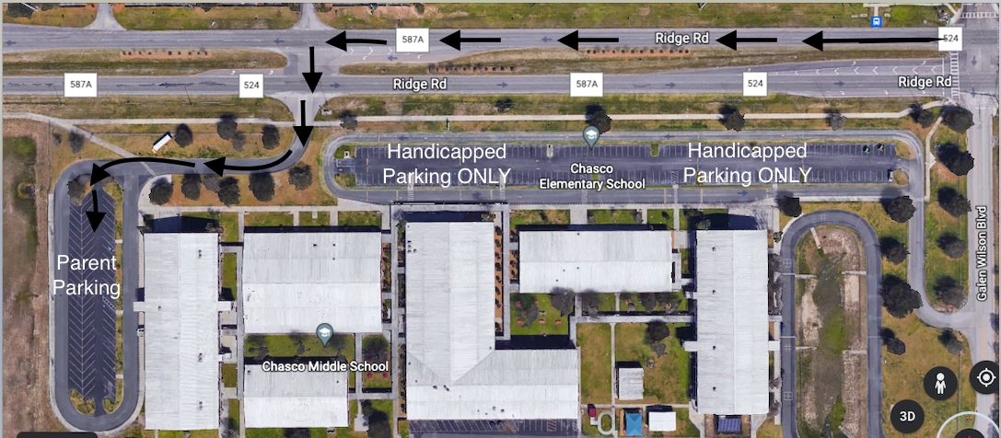

If you have any questions or concerns, please feel free to contact Chasco Middle at (727) 774-1300.

Sincerely,
CHMS Administration

