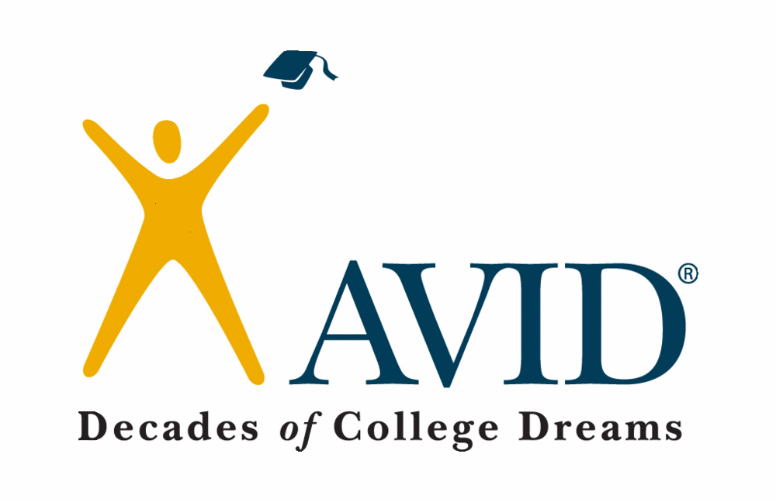

Are You…
- interested in going to college?
- tired of making average grades or not
reaching your full potential?
- motivated to learn but not always
sure how to succeed?
- ready to raise the bar and become a
top HONORS student?
- desiring free tutoring during the school
day to assist you in classes?
- desiring an elective with other students
who really want to be at school and learn?

Then AVID could
be for you!
Fill out the application and return it to
Ms. Peterson in the back office.
Application Due Monday, April 25, 2016.

What AVID is…

The mission of AVID (Advancement Via Individual Determination) is to ensure that ALL students, especially those who find themselves “in the middle,” will succeed in rigorous curriculum, will complete a college prep path, and will become educated and responsible participants and leaders in society.

The AVID student…

- Makes As, Bs, and even an occasional C
- Has the desire to go to college
- Is willing to work hard
- Is capable of completing rigorous curriculum
- May fall short of his/her potential without AVID
- Is in need of acceleration, not remediation
- Practices good citizenship
- Has good attendance
- Earns average to high test scores
- Maintains a 2.5 or higher GPA
- Takes notes in all classes
- Is on-track
- Studies with a purpose daily

The AVID application process…

- Fill out the application completely and neatly in pen. Typed responses are also acceptable.
- Ask two teachers to fill out the recommendation AND follow up by giving a Thank You note to each one.
- Turn in completed application to Ms. Peterson in the back office.
- Be ready for an interview with the school’s AVID Site Team.

Check out http://www.avid.org/secondary.ashx for more information. Contact Lauren Pantoja, CHMS AVID Coordinator, lpantoja@pasco.k12.fl.us , or
David Huyck, Principal, dhuyck@pasco.k12.fl.us , or 727-774-1301
if you have any questions.
Chasco Middle School
AVID Application

Please complete neatly in ink.
Student Name
Current Grade & School
Parent/Guardian Name
Mailing Address
Home Phone
Cell Phone
Parent Email
Student Email

What is the highest level of education of:
Your Father
Your Mother

Grades | Math | Science | SS | LA | Elec. | Elec.
Current
Last Qtr.
# of Missing Assignments
- Please attach an eSembler summary.

What does your homework/study routine look like?

In your opinion, what is the most difficult aspect of school?
What are your goals for middle school, high school, and after?

What activities are you involved in at school and/or in the community?

Use the 1-4 scale (where 1 is not important and 4 is extremely important) to rate the following with how YOU feel and how you think your family feels.
Question | You | Your Family
How important is it for you to go to a 4-year college? | 1 2 3 4 | 1 2 3 4
How important is it to complete all of your class assignments? | 1 2 3 4 | 1 2 3 4
How important is it to make straight As? | 1 2 3 4 | 1 2 3 4
How important is it to get into the AVID program? | 1 2 3 4 | 1 2 3 4

Personal Essay
Use the space on the back of the page (or attach a document) to describe yourself. Think about the following questions as you write. What makes you unique? What kind of learner/student are you? Why would you like to be considered for AVID at Chasco Middle? Make sure you edit and have someone proofread before final submission.

By signing below, I give permission for my student to apply for AVID and understand my role is to fully support him/her by being as involved as possible in my student’s education.
Parent Signature ____________________________________________________

By signing below, I understand my responsibilities should I be chosen as an AVID student. I am fully committed to working hard and preparing myself for college.

Student Signature ___________________________________________________

TWO TEACHER RECOMMENDATIONS ARE REQUIRED FOR YOUR APPLICATION TO BE CONSIDERED. PLEASE CUT THE LAST SHEET OF THIS APPLICATION IN HALF, FILL IN YOUR NAME, AND GIVE TO TWO TEACHERS OF YOUR CHOICE.

The following student is applying for the AVID program. Teacher recommendations are a vital part of successful placement. Please take a moment to complete the Survey Monkey survey located at:
AVID Teacher Recommendation

https://www.surveymonkey.com/r/32KSCC9

Thank you in advance for your help. If you cannot get this link to work, please email Lauren Pantoja at lpantoja@pasco.k12.fl.us for assistance.

Student Name _______________________________________________

-----------------------------------------------------------------------------------------------------

The following student is applying for the AVID program. Teacher recommendations are a vital part of successful placement. Please take a moment to complete Survey Monkey survey located at:
AVID Teacher Recommendation

https://www.surveymonkey.com/r/32KSCC9

Thank you in advance for your help. If you cannot get this link to work, please email Lauren Pantoja at lpantoja@pasco.k12.fl.us for assistance.

Student Name _______________________________________________

